



Allergy Awareness Policy

Version: | 2
Ratified by the Finance, audit & Risk Committee
Signed by the Finance, audit & Risk Committee |  | Date: 09.07.2026
To be reviewed every 2 years |  | Date: 09/07/2028

Contents
1. Introduction 3
2. Roles and Responsibilities 5
3. Teaching staff 5
4. Support staff 6
5. Office Manager 6
6. Premises Manager 6
7. Kitchen manager and catering staff 7
8. Contractors and visitors 8
9. Pupils and parents 9
10. Arrangements 10
11. First Aid 11
12. Insurance Arrangements 11
13. Educational Visits 12
14. Administering Medicines 12
15. Storage/Disposal of Medicines 12
16. Anaphylaxis 13
17. Accidents/Illnesses requiring Hospital Treatment 14
18. Defibrillators 15
19. Students with Special Medical Needs – Individual Healthcare Plans 15
20. Accident Recording and Reporting 16
21. Reporting to the HSE 17
22. Food Allergens 19
23. Conclusions 21
24. Appendix 1 - Health Care Plan 22
25. Appendix 2A – Pupil Allergy Declaration Form 27
26. Appendix 2B – Staff Allergy Declaration Form 29
27. Appendix 3 - Parental agreement to administer medicine 31
28. Appendix 4 – EpiPen®: Emergency Instructions 33
29. Appendix 5 – ANAPEN®: Emergency Instructions 35
30. Appendix 6 – Emergency Contact Numbers 37
31. Appendix 7 – Note to parent/carer for medication given 39
32. Appendix 8 - Contacting Emergency Services 40
33. Appendix 9 - Checklist for Responding to Emergency Situations 42
34. Further Guidance 43
35. Changes 46

- Introduction
The Board of Trustees believe that ensuring the health and welfare of staff, students and visitors is essential to the success of the academy and is committed to ensuring that those with medical conditions, including allergies, especially those likely to have a severe reaction (anaphylaxis), are supported in all aspects of academy life.
This policy has been updated to reflect statutory guidance arising from Benedict’s Law (2026) and associated Department for Education requirements relating to allergy management and anaphylaxis preparedness.
We will:
        - Adhere to current legislation and statutory guidance, including requirements introduced through Benedict’s Law regarding allergy safety.
        - Maintain and publish a whole-academy Allergy Awareness Policy, reviewed regularly and accessible to stakeholders.
        - Ensure all staff (including supply staff, contractors and support staff) receive mandatory allergy awareness and anaphylaxis training, refreshed at appropriate intervals.
        - Ensure sufficient trained staff are available at all times to recognise and respond to allergic reactions, including administering adrenaline auto-injectors (AAIs).
        - Ensure spare, in-date adrenaline auto-injectors are held on site, in accordance with national guidance, for emergency use.
        - Maintain Individual Healthcare Plans (IHPs) for all students with diagnosed allergies.
        - Ensure robust incident reporting, recording and review processes are in place for all allergic incidents and near misses.
        - Raise awareness of allergies and anaphylaxis across the whole academy community.
        - Conduct risk assessments for all students with allergies and review these regularly.
        - Aim to reduce the risk of exposure to allergens to an acceptably low level.
  - Whilst we will endeavour to ensure our academy provides a safe environment for all, we cannot guarantee our academy will be allergen-free.
In the event of illness, a staff member will accompany the student to:
Kingsbury Academy
Academy SLT office/medical room
The Warwickshire Academy
First Aid Room
Calthorpe Academy
Academy office/medical room
Baginton Fields
Nurses Room
Corley Academy
Academy Office
Mary Elliott
Office
Kitts Greed Academy
Medical Room

  - To manage their medical condition effectively, the academy will not prevent students from eating, drinking, or taking breaks whenever they need to.
  - The academy also has a First Aid and Administration of Medicines Policy, which may also be relevant, and all staff should be aware of.
  - This policy applies to all relevant academy activities and is written in compliance with all current UK health and safety legislation and has been consulted with staff and their safety representatives (Trade Union and Health and Safety Representatives).
- Roles and Responsibilities
  - The Trust Board
      - The Trust Board has ultimate responsibility for health and safety matters - including Allergy Awareness in the academy.
      - Ensure the Allergy Awareness Policy is reviewed annually and/or after any operational changes, to ensure that the provisions remain appropriate for the activities undertaken.
      - Ensure compliance with Benedict’s Law statutory guidance and associated regulatory requirements.
      - Seek assurance that allergy management systems, training, and emergency arrangements are effective and auditable

  - The Headteacher
      - Carry out a risk assessment of allergy needs of students and staff, appropriate to the circumstances of the workplace, and review annually and/or after any significant changes.
      - Ensuring that an appropriate number of appointed persons have been provided with allergy awareness training and that their names are prominently displayed throughout the academy.
      - Ensuring that appointed staff have an appropriate qualification, keep training up to date and remain competent to perform their role.
      - Ensuring all staff are aware of the academy allergy awareness procedures.
      - Ensuring appropriate allergy awareness assessments are completed and appropriate measures are put in place.
      - Ensuring that catering is provided to the reasonable medical needs of staff and students.
      - Ensure allergy bullying is treated seriously, like any other bullying.
      - Reporting specified incidents to the Health and Safety Executive (HSE), when necessary.
      - Ensure a named Allergy Lead (or equivalent) is appointed.
      - Ensure training records are maintained and auditable.

- Teaching staff
      - Complete mandatory allergy awareness and anaphylaxis training.
      - Ensuring they follow allergy awareness procedures.
      - Ensuring they know who the first aiders in academy are and contact them straight away.
      - Completing accident reports for all incidents they attend to where a first aider is not called.
      - Informing the Headteacher or their manager of any specific health conditions or allergy needs.

- Support staff
      - Complete mandatory allergy awareness and anaphylaxis training.
      - Ensuring they know who the first aiders in academy are and contact them straight away.
      - Completing accident reports for all incidents they attend to where a first aider is not called.
      - Informing the Headteacher or their manager of any specific health conditions or allergy needs

- Office Manager
      - Complete mandatory allergy awareness and anaphylaxis training.
      - Ensuring they follow allergy awareness procedures.
      - Ensuring they know who the first aiders in academy are and contact them straight away.
      - Completing accident reports for all incidents they attend to where a first aider is not called.
      - Informing the Headteacher or their manager of any specific health conditions or allergy needs.

- Premises Manager
      - Complete mandatory allergy awareness and anaphylaxis training.
      - Ensuring they follow allergy awareness procedures.
      - Ensuring they know who the first aiders in academy are and contact them straight away.
      - Completing accident reports for all incidents they attend to where a first aider is not called.
      - Informing the Headteacher or their manager of any specific health conditions or allergy needs.

- Kitchen manager and catering staff
      - The Academy has an Allergy Awareness Policy; the catering manager is responsible for ensuring that the Food Allergy requirements are reviewed and reflective of the current menu offerings.
      - All catering staff and catering support staff have received Allergy Awareness Training & records retained https://allergytraining.food.gov.uk/ certification is retained and refresher training is provided in line with the training schedule.
      - The catering team have received all staff and student allergy requirements, the information is retained and reviews are undertaken. Any food allergies are reported to the catering team.
      - The Allergen Matrix is made available for dishes served - this will be dated and current to the menu offering for that day/week/fortnight and should cover all items on the menu offering. Menus clearly identify ingredients that may pose a risk to allergy sufferers, enabling informed choices to be made.
      - All dishes will be reviewed for allergen contents & that the catering team continue to review the individual ingredients. The frequency will be determined by the change in products delivered, new suppliers appointed and on a regular basis (As suppliers may substitute ingredients or products that previously didn’t have an allergen contained, therefore the packaging label should be crossed checked with the school’s allergen matrix & updated when required, the catering manager will redate the allergen matrix to reflect the review).
      - All purchased pre-packaged items have been provided with the list of all ingredients and that the allergen details provided are in bold. To report to supplier if any products have been delivered without the required legal labelling, and the product will not be used, until clarification of any allergens has been received by the manufacturer or supplier.
      - Rigorous food hygiene is maintained to reduce the risk of cross-contamination.
      - Cross-contamination is the physical movement or transfer of allergens from one person, object or place to another food item. Preventing cross-contamination is a key factor in preventing potential allergic reactions.
  - Controlling allergen cross-contamination
      - Any foods/dishes with any of these 14 allergens in must be carefully stored and handled in the kitchen so to prevent the risks of cross-contamination.
      - Staff training on kitchen procedures to prevent cross-contamination during storage, preparation and serving of food.
      - Cleaning utensils before each usage, especially if they were used to prepare meals containing allergens
      - A storage system should be in place to prevent cross-contamination of ingredients with other ingredients containing allergens. Keeping ingredients that contain allergens separate from other ingredients
      - Have a spillage plan in place to clean up allergenic ingredients: You should use disposable clothes/towels / blue rolls to prevent cross-contamination.
      - Effective cleaning, washing up and hand washing using hot water, cleaning and sanitising products.
      - Physical separation – putting a lid or cover on food, using a clean knife, board, plate, pan, working area, and aprons.
      - Using separate fryers/cooking equipment.
  - Allergen cross-contamination can also happen through using the same cooking oil. To cook gluten-free chips, you can’t use the same oil which has been previously used for cooking battered fish.
  - If you can’t avoid cross-contamination in food preparation, you should inform customers that you can’t provide an allergen-free dish.
- Contractors and visitors
To ensure:
  - The academy’s Allergy Policy and reporting procedure is followed
  - Their activities do not introduce an allergy risk to the Academy.
  - A high standard of hygiene is maintained whilst in academy premises as a matter of good practice.
  - Any areas which may be contaminated are to be reported to the Facilities Team or their host.

- Pupils and parents
  - The parents or carers of all new starters to the school are required to inform the academy of any details of any food intolerances or allergies and their management should be described by completing the Allergy Declaration Form (Appendix 2).
  - If details are unclear or ambiguous, the academy will follow this up with a phone call to parents for further information which will be recorded by the academy.
  - It is parents’ responsibility to ensure that if their child’s medical needs change at any point that they make the academy aware and a revised medical needs form must be completed. Updating the school if their child’s medical needs change at any point. Parents are requested to keep the academy up to date with any changes in allergy management with regards to clinic summaries, re-testing and new food challenges.
  - Ensuring that any required medication (EpiPens or other adrenalin injectors, inhalers and any specific antihistamine) is supplied, in date and replaced as necessary. The parents of all children who have an epi-pen in school must complete specific healthcare plan sheets stating the emergency actions to be taken. They should also give permission for the spare emergency epi-pen to be used in the event it is required.
  - Attending any meeting as required to share further information about their child’s food allergy, to plan for food management in school or to complete a care plan.
  - If an episode of anaphylaxis occurs outside school, the academy must be informed.
  - Children of any age must be familiar with what their allergies are and the symptoms they may have that would indicate a reaction is happening.
  - Children are encouraged to take increased responsibility for managing choices that will reduce the risk of allergic reactions. Expectations are age appropriate.
  - Children are not allowed to share food with each other.
  - Members of staff or volunteers will be asked to disclose any food allergies as part of their induction.
- Arrangements
  - A whole-academy allergy policy is implemented and regularly reviewed.
  - All staff receive mandatory training in allergy awareness and anaphylaxis response.
  - Individual Healthcare Plans (IHPs) are maintained and shared appropriately.
  - Clear communication systems are in place with parents and carers.
  - Students’ medication is stored in:
Kingsbury Academy
Medical Room/ School Office for refrigerated medicines.
The Warwickshire Academy
The classroom in a secure locked cabinet and/or the medication cabinet located in the first aid room
Calthorpe Academy
Auto injectors are in green medication bags (allocated to and worn by a member of staff supporting at all times)
Mary Elliott
In treatment room.
Baginton Fields
Within nurses Room

Corley Academy
Medication kept inside a locked cupboard in named zipped wallets in school office. Medication that requires refrigeration is securely kept in ground floor kitchen fridge.
Kitts Green Academy
Medication is kept in the medical room

  - Students who’s auto injectors are kept by the academy are clearly detailed on the Health Care Plan (Appendix 1) and Allergy Declaration Form (Appendix 2)
  - Spare adrenaline auto-injectors (AAIs) are available, in date, and accessible
  - Student Allergy Declaration Forms are completed and stored:
Kingsbury Academy
Medical Folder in the SLT office and School Office
The Warwickshire Academy
First aid room
Calthorpe Academy
S:\Medical Information\Allergies & Anaphylaxis\Pupil Allergy Care Plans
Corley Academy
Information is uploaded to Arbor and available to staff.
Mary Elliott
Medical information uploaded to Arbor.
Baginton Fields
Loaded onto SharePoint and available to staff

  - A copy of the Allergy Declaration Form, when containing Food Allergies is also provided to the catering team.

- First Aid
In the case of a student’s anaphylactic shock, the procedures are as follows:
- The member of staff on duty calls for a first aider; or if the child can walk, takes him/her to a first aid post and calls for a first aider.
- The first aider administers first aid and records details in our treatment book.
- Full details of the accident are recorded in our accident book
- If the child has to be taken to hospital or the injury is `work’ related then the accident is reported to the Governing Body.
- If the incident is reportable under RIDDOR (Reporting of Injuries, Diseases & Dangerous Occurrences Regulations 2013) the person responsible for reporting this in each Academy is outlined in our Health & Safety Policy.
- At least one trained member of staff will always be available who is competent in:
  - recognising anaphylaxis
  - administering adrenaline auto-injectors

- Emergency response procedures will be tested periodically (e.g. drills or scenario reviews).

- Insurance Arrangements
Risk Protection Arrangement (RPA)
0330 058 5566

- Educational Visits
  - In the case of a residential visit, the residential first aider will administer First Aid. Reports will be completed in accordance with procedures at the Residential Centre.
  - In the case of day visits a trained First Aider will carry a travel kit in case of need, including a spare auto-injector required for the pupil’s needs.
  - Any pupil with a prescribed auto-injector must carry this on any educational visit.
  - Where packed lunches are provided for day visits, the catering team will adhere to providing food taking into account the pupil’s known allergies.
  - Where food is provided by a 3rd Party caterer on a day or residential trip, they will be provided with all known allergies of the pupils attending the educational visit.

- Administering Medicines
  - Prescribed medicines may be administered in academy (by a staff member appropriately trained by a healthcare professional) where it is deemed essential. Wherever possible, the student will administer their own medicine, under the supervision of a member of staff. In cases where this is not possible, the staff member will administer the medicine.
  - If a child refuses to take their medication, staff will accept their decision and inform the parents accordingly.
  - In all cases, we must have written parental permission outlining the type of medicine, dosage and the time the medicine needs to be given. These forms are available in the academy office. (See Appendix 2 for Allergy Declaration and Appendix 3 Parental Agreement)
  - Staff will ensure that records are kept of any medication given.
  - Non-prescribed medicines must not be taken in academy.

- Storage/Disposal of Medicines
  - Wherever possible, children will be allowed to carry their own medicines/ relevant devices or will be able to access their medicines in the academy office for self-medication, quickly and easily. Students’ medicine will not be locked away out of the student’s access; this is especially important on academy trips. It is the responsibility of the academy to return medicines that are no longer required, to the parent for safe disposal.
  - Spare Auto Injectors (Epi Pens) will be held by the Academy for emergency use, as per the Department of Health’s protocol. Spare Auto Injectors (AAIs) will be:
      - Clearly labelled
      - Stored in known, accessible, non-locked locations
      - Checked regularly for expiry dates
      - Included in routine compliance checks

- Anaphylaxis
  - Anaphylaxis is a severe and potentially life-threatening reaction to a trigger such as an allergy. Anaphylaxis usually develops suddenly and gets worse very quickly
The symptoms include:
- feeling lightheaded or faint
- breathing difficulties – such as fast, shallow breathing
- wheezing
- a fast heartbeat
- clammy skin
- confusion and anxiety
- collapsing or losing consciousness

  - There may also be other allergy symptoms, including an itchy, raised rash (hives); feeling or being sick; swelling (angioedema) or stomach pain.
  - What to do if someone has anaphylaxis. Anaphylaxis is a medical emergency. It can be very serious if not treated quickly. If someone has symptoms of anaphylaxis, you should:
- Use an adrenaline auto-injector if the person has one – but make sure you know how to use it correctly first.
- Call 999 for an ambulance immediately (even if they start to feel better) – mention that you think the person has anaphylaxis.
- Remove any trigger if possible – for example, carefully remove any stinger stuck in the skin.
- Lie the person down flat – unless they're unconscious, pregnant or having breathing difficulties.
- Give another injection after 5 to 15 minutes if the symptoms do not improve and a second auto-injector is available.

  - People with potentially serious allergies are often prescribed adrenaline auto-injectors to carry at all times. These can help stop an anaphylactic reaction from becoming life-threatening.
  - They should be used as soon as a serious reaction is suspected, either by the person experiencing anaphylaxis or someone helping them.
  - Make sure you're aware of how to use your type of auto-injector correctly. And, carry 2 of them with you at all times.
  - There are 3 main types of an adrenaline auto-injector, which are used in slightly different ways. It is therefore important that staff have sufficient training and awareness of how to use the auto-injectors.

These are:
EpiPen
Jext
Emerade

- Accidents/Illnesses requiring Hospital Treatment
  - If a student has an incident, which requires urgent or non-urgent hospital treatment, the academy will be responsible for calling an ambulance in order for the child to receive treatment. When an ambulance has been arranged, a staff member will stay with the student until the parent arrives, or accompany a child taken to the hospital by ambulance if required.
  - Parents will then be informed, and arrangements made regarding where they should meet their child. It is vital therefore, that parents provide the academy with up-to-date contact names and telephone numbers.

- Defibrillators
  - Where academies have defibrillators as part of the first aid equipment they will ensure First aiders are trained in the use of these.
  - The local NHS ambulance service have been notified of its location.

- Students with Special Medical Needs – Individual Healthcare Plans
  - Some students have medical conditions that, if not properly managed, could limit their access to education. These children may be:
      - Epileptic
      - Asthmatic
      - Have severe allergies, which may result in anaphylactic shock
      - Diabetic
  - Such students are regarded as having medical needs. Most children with medical needs are able to attend academy regularly and, with support from the academy, can take part in most academy activities, unless evidence from a clinician/GP states that this is not possible.
  - The academy will consider what reasonable adjustments they might make to enable children with medical needs to participate fully and safely on academy visits. A risk assessment will be used to take into account of any steps needed to ensure that students with medical conditions are included.
  - The academy will not send students with medical needs home frequently or create unnecessary barriers to students participating in any aspect of academy life. However, academy staff may need to take extra care in supervising some activities to make sure that these students, and others, are not put at risk.
  - An individual health care plan will help the academy to identify the necessary safety measures to support students with medical needs and ensure that they are not put at risk. The academy appreciates that students with the same medical condition do not necessarily require the same treatment.
  - Parents/carers have prime responsibility for their child’s health and should provide the academy with information about their child’s medical condition. Parents, and the student if they are mature enough, should give details in conjunction with their child’s GP and Paediatrician.
Kingsbury Academy
The Assistant Head Teacher and School Nursing Team
The Warwickshire Academy
The Local Authority professional healthcare staff and senior pastoral staff
Calthorpe Academy
The BCHC Plus (Birmingham Community Health Care, NHS) may also provide additional background information and practical training for academy staff.
Baginton Fields Academy
Information held on SharePoint.
Corley Academy
Uploaded onto Arbour for staff to check.
Mary Elliot
Uploaded to Arbour – HLTA manages information.
Kitts Green Academy
Uploaded onto Arbour for staff to check.

  - Procedure that will be followed when the academy is first notified of a student’s medical condition:
      - All Pupils will have an Individual Health Care Plan (Appendix 1) and where required an Allergy Declaration Form (Appendix 2). This will be held centrally and shared with the required staff within the academy.
      - This will be in place in time for the start of the relevant term for a new student starting at the academy or no longer than two weeks after a new diagnosis or in the case of a new student moving to the academy mid-term.

- Accident Recording and Reporting
First aid and accident record book
      - An accident form will be completed by the relevant member of staff on the same day or as soon as possible after an incident resulting in an anaphylactic shock. A copy will be emailed or printed out and sent to parents.
      - As much detail as possible should be supplied when completing the accident form – which must be completed fully.
      - A copy of the accident report form will also be added to the student’s educational record by the relevant member of staff.
      - Records held in the first aid and accident book will be retained by the academy for a minimum of 3 years, in accordance with regulation 25 of the Social Security (Claims and Payments) Regulations 1979, and then securely disposed of.
- Reporting to the HSE
      - The Headteacher will keep a record of any accident which results in a reportable injury, disease, or dangerous occurrence as defined in the RIDDOR 2013 legislation (regulations 4, 5, 6 and 7) and a copy will be sent to the Estates Manager.
      - The Headteacher or delegated Health & Safety Lead (as detailed in our Health & Safety Policy) will report these to the Health and Safety Executive as soon as is reasonably practicable and in any event within 15 days of the incident. Reportable injuries, diseases or dangerous occurrences include:
        - Death
Specified injuries, which are:
        - Fractures, other than to fingers, thumbs and toes
        - Amputations
        - Any injury likely to lead to permanent loss of sight or reduction in sight
        - Any crush injury to the head or torso causing damage to the brain or internal organs
        - Serious burns (including scalding)
        - Any scalping requiring hospital treatment
        - Any loss of consciousness caused by head injury or asphyxia
        - Any other injury arising from working in an enclosed space which leads to hypothermia or heat-induced illness, or requires resuscitation or admittance to hospital for more than 24 hours
        - Injuries where an employee is away from work or unable to perform their normal work duties for more than 7 consecutive days (not including the day of the incident).
  - Where an accident leads to someone being taken to hospital
Near-miss events that do not result in an injury but could have done. Examples of near-miss events include, but are not limited to:
        - The collapse or failure of load-bearing parts of lifts and lifting equipment.
        - The accidental release of a biological agent likely to cause severe human illness.
        - The accidental release or escape of any substance that may cause a serious injury or damage to health.
        - An electrical short circuit or overload causing a fire or explosion.
        - Information on how to make a RIDDOR report is available here:
http://www.hse.gov.uk/riddor/report.htm

  - Notifying parents
      - The first aider who has administered the first aid check will inform parent/carer of any accident or injury sustained by the student, and any first aid treatment given, on the same day.
      - Reporting to Ofsted and child protection agencies
      - Registered Early Years Providers will notify Ofsted of any serious accident, illness or injury to, or death of, a student while in their care. This will happen as soon as is reasonably practicable, and no later than 14 days after the incident.
      - The Headteacher will also notify the relevant Local Authority of any serious accident or injury to, or the death of, a student while in the academy care.

  - Difference between Food Allergy and Food Intolerance
      - A food allergy is when the body’s immune system (which is the body's defense against infection) mistakenly treats the protein in food as a threat. The body responds to this threat by releasing a number of chemicals in the body. These chemicals cause the symptoms of an allergic reaction.
      - A Food intolerance is more common than a food allergy. Food intolerances are thought to affect 1 in 10 people. Food intolerances do not involve the immune system. Instead, a food intolerance involves the digestive system and can cause difficulty digesting certain foods leading to symptoms such as abdominal pain, gas and diarrhea. Those who are affected often rely on allergen labelling to avoid the foods that make them ill.

- Food Allergens
The Food Information (Amendment) (England) Regulations 2019
  - The UK Food Information Amendment, also known as Natasha’s Law, came into effect on the 1st of October 2021 and requires food businesses to provide full ingredient lists and allergen labelling on foods pre-packaged for direct sale on the premises. The legislation was introduced to protect allergy sufferers and give them confidence in the food they buy.
  - Under the new rules, food that is pre-packaged for direct sale (PPDS) must display the following clear information on its packaging:
        - The food’s name
        - A full list of ingredients, emphasising any allergenic ingredients.
  - For schools, the new labelling requirements will apply to all food they make on-site and package, such as sandwiches, wraps, salads, and cakes. It applies to food offered at mealtimes and as break-time snacks. And, as mentioned earlier, it will apply to food the pupils select themselves or that caterers keep behind the counter.
  - Food businesses need to tell customers if any food they provide contains any of the listed allergens as an ingredient.
  - Consumers may be allergic or have an intolerance to other ingredients, but only the 14 allergens are required to be declared as allergens by food law in the UK.
  - The main 14 allergens (as listed in Annex II of the EU Food Information for Consumers) are:
      - Cereals containing gluten, namely wheat (such as spelt and Khorasan wheat), rye, barley and oats
      - Crustaceans, Invertebrates (they have no backbone) with a segmented body and jointed legs. Crab, crayfish, langoustine, lobster, prawn, shrimp, scampi.
      - Egg, Egg does not have to be eaten to cause an allergic reaction; coming into contact with eggshells or touching (raw) egg can cause allergic symptoms usually affecting just the skin in highly sensitive individuals.
      - Fish, Vertebrates (they have a backbone). Most fish are covered in scales and have fins. Anchovy, Basa, cod, cuttlefish, haddock, hake, halibut, mackerel, monkfish, pilchards, plaice, pollock, salmon, sardine, sea bass, swordfish, trout, tuna, turbot, whitebait.
      - Peanuts, Different varieties of peanuts are produced for different uses (for example, peanuts to be used in peanut butter and peanuts in the shell for roasting,). Peanuts are from a family of plants called legumes, the same family as garden peas, lentils, soya beans and chickpeas. Most people will be able to eat other types of legumes without any problems and it is rare for people with a peanut allergy to react to other legumes.
      - Peanut allergy affects around 2% (1 in 50) of children in the UK and has been increasing in recent decades.
      - Soybeans, Soy comes from soybeans and immature soybeans are called edamame beans. Soya can be ingested as whole beans, soya flour, soya sauce or soya oil. Soya can also be used in foods as a texturiser (texturised vegetable protein), emulsifier (soya lecithin) or protein filler. Soya flour is widely used in foods including; breads, cakes, processed foods (ready meals, burgers, and sausages) and baby foods.
      - Milk, includes dairy items, butter, cheese, cream, yoghurt, ice-cream, ghee, whey, buttermilk, milk powders.
      - Nuts (namely almond, hazelnut, walnut, cashew, pecan nut, Brazil nut, pistachio nut and macadamia nut (Queensland nut). Can be found in curry powders and mixes, savoury sauces, salad dressing, marinades, soup, Indian dishes, English, French and American dishes
      - Celery, celery sticks, celery leaves, celery spice, celery seeds, which can be used to make celery salt.
      - Mustard, Mustard seeds are produced by the mustard plant which is a member of the Brassica family. Seeds can be white, yellow, brown or black. Whole seeds can be used in a variety of ways in cooking including roasting, marinating or as an addition to pickled products. Whole, ground, cracked or bruised mustard seeds are mixed with other ingredients to make table mustard.
      - Sesame seeds, Also known as: Benne (African name), gingelly (Sesame Oil), gomashio (Japanese Condiment), til (seed of sesame) Foods that sometimes have sesame as an ingredient include: veggie burgers, breadsticks, crackers, burger buns, cocktail biscuits, Middle Eastern foods, Chinese, Thai and Japanese foods, stir-fry vegetables, salad dishes and health food snacks.
      - Sulphur dioxide and/or sulphites, Also known as: Sulphur dioxide (E220) and other sulphites (from numbers E221 to E228) are used as preservatives in a wide range of foods, especially soft drinks, sausages, burgers, and dried fruits and vegetables.
      - E220 (Sulphur dioxide), E221 Sodium sulphite, E222 Sodium hydrogen sulphite, E223 Sodium metabisulphite, E224 Potassium metabisulphite, E226 Calcium sulphite, E227 Calcium hydrogen sulphite, E228 Potassium hydrogen sulphite, E150b Caustic sulphite caramel, E150d Sulphite ammonia caramel. It can be found in foods as a preservative, dried fruit and vegetables, soft drinks, fruit juices, fermented drinks (wine, beer and cider), sausages and burgers. Anyone who has asthma or allergic rhinitis may react to inhaling sulphur dioxide.
      - Lupin, Also known as lupin seeds, lupin beans and lupin flour. The lupin is well-known as a popular garden flower with its tall, colourful spikes. The seeds from certain lupin species are also cultivated as food. These are normally crushed to make lupin flour, which can be used in baked goods such as pastries, pies, pancakes and in pasta.
      - Molluscs, Also invertebrates. They are soft bodied inside and some have a shell. Abalone, squid, cuttlefish, octopus, snails and whelk. Those that have a shell that opens and closes are called ‘bivalve molluscs’, such as clams, cockles, oysters, mussels and scallops. This also applies to additives, processing aids and any other substances which are present in the final product.

- Conclusions
  - This Allergy Awareness Policy reflects the academy’s commitment to meeting its statutory duties under current legislation, including Benedict’s Law (2026). The academy has established robust systems for allergy prevention, awareness, and emergency response.
  - Clear lines of responsibility, effective training, appropriate provision of emergency medication, and continuous review ensure that the academy provides a safe environment for all students, staff, and visitors.
  - The storage, organisation and administration of first aid and medicines provision is taken very seriously. The academy carries out regular reviews to check the systems in place meet the objectives of this policy.
- Appendix 1 - Health Care Plan

Academy
Student Name & Address
Date of Birth
Class
Medical Diagnosis
Triggers
Who needs to know about the student’s condition and what constitutes an emergency?

Action to be taken in emergency and by whom
Follow Up Care
Family Contacts
Names
Telephone Numbers
Clinic/Hospital Contacts
Name
Number
GP
Name
Number
Description of medical needs and signs and symptoms
Daily Care Requirements
Who is Responsible for Daily Care

Transport Arrangements
If the student has a life-threatening condition, specific transport healthcare plans will be carried on vehicles
Academy Trip Support/Activities outside school Hours
(e.g. risk assessments, who is responsible in an emergency)
Form Distributed To

Date

Review date

This will be reviewed at least annually or earlier if the child’s needs change
Arrangements that will be made in relation to the child travelling to and from the academy. If the student has a life-threatening condition, specific transport healthcare plans will be carried on vehicles

Calthorpe Additional Information
EpiPen
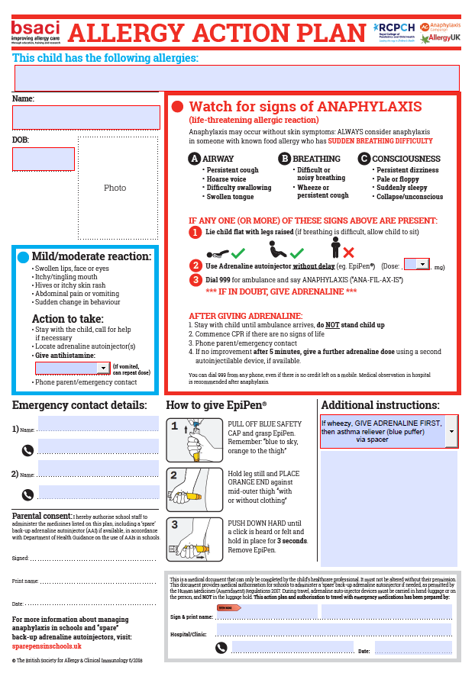

Jenx
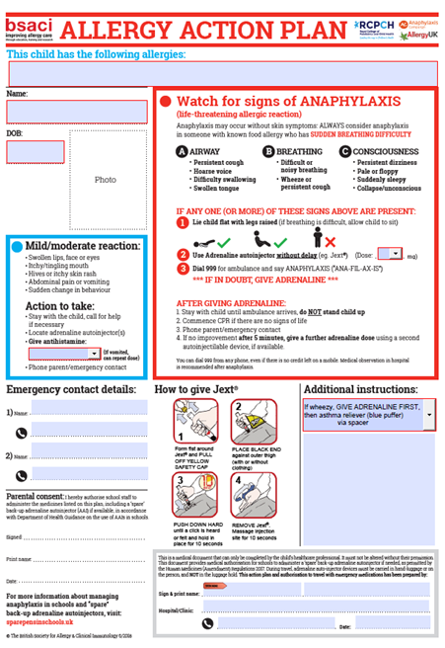

Emerade

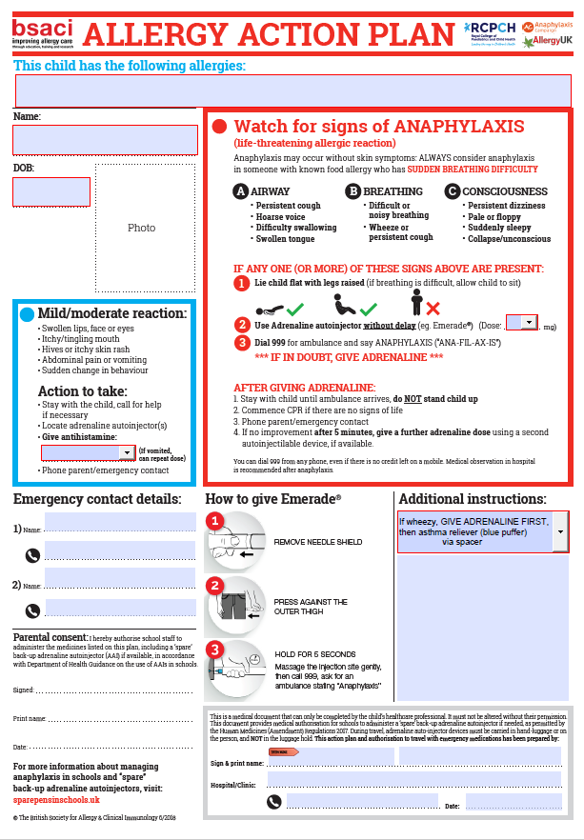

- Appendix 2A – Pupil Allergy Declaration Form

Name of pupil:
Date of birth: |  | Year group:
Name of GP:
Address of GP:

Nature of allergy:

Severity of allergy:

Symptoms of an adverse reaction:
Details of required medical attention:

Instructions for administering medication:
Control measures to avoid an adverse reaction:

Date

Review date

This will be reviewed at least annually or earlier if the child’s needs change
Arrangements that will be made in relation to the child travelling to and from the academy. If the student has a life-threatening condition, specific transport healthcare plans will be carried on vehicles
Calthorpe Additional Information
Pupil Allergy Action Plan
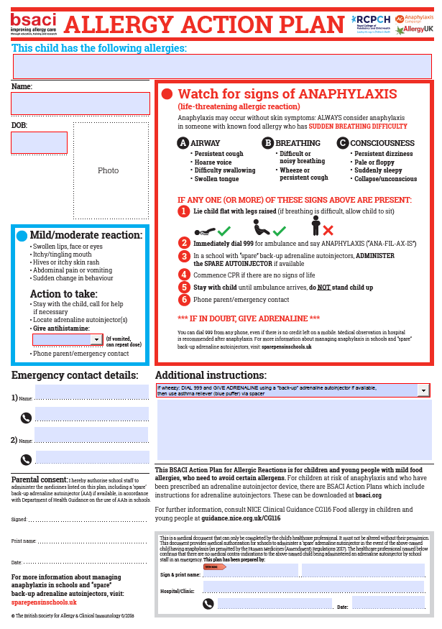
- Appendix 2B – Staff Allergy Declaration Form

Name of Staff:
Date of birth: |  | Position:
Name of GP:
Address of GP:

Nature of allergy:

Severity of allergy:
Symptoms of an adverse reaction:
Details of required medical attention:

Instructions for administering medication:
Control measures to avoid an adverse reaction:

Date
Review date
This will be reviewed at least annually or earlier if the staff’s needs change

- Appendix 3 - Parental agreement to administer medicine

One form is to be completed for each medicine.
The academy will not give your child medicine unless this form is fully completed and signed.

Name of child

Date of Birth ________/______/______

Medical condition or illness

Medicine: To be in the original container with the label as dispensed by a pharmacy

Name/type and strength of the medicine
(as described on the container)

Date commenced ________/______/______

Dosage and method

Time to be given

Special precautions

Are there any side effects that the
academy should know about?

Self-administration Yes/No (delete as appropriate)

Procedures to take in an emergency

Parent/Carer Contact Details:
Name

Daytime telephone no.

Relationship to child
Address
I understand that I must deliver the medicine safely to the academy office.
The above information is, to the best of my knowledge, accurate at the time of writing and I give consent to appropriately trained academy staff administering medicine in accordance with the academy policy. I will inform the academy immediately, in writing, if there is any change in dosage or frequency of the medication or if the medicine is stopped.

Parent/Carer’s signature
Print Name
Date

- Appendix 4 – EpiPen®: Emergency Instructions
EpiPen®: EMERGENCY INSTRUCTIONS FOR AN ALLERGIC REACTION

Child’s Name:
DOB:
Allergic to:

ASSESS THE SITUATION
Send someone to get the emergency kit, which is kept in:
Kingsbury Academy: Medicine Cupboard / First Aid Room
The Warwickshire Academy: A locked cabinet located in the first aid room/ in a secure cabinet in the child’s classroom
Calthorpe Academy: Green medication bags (allocated to and worn by a member of staff supporting at all times)
Mary Elliot: Treatment Rooms
Corley Academy: Locked inside main office
Baginton Fields: Nurses Room

IT IS IMPORTANT TO REALISE THAT THE STAGES DESCRIBED BELOW MAY MERGE INTO EACH OTHER RAPIDLY AS A REACTION DEVELOPS

Mild Reaction
ACTION
- Give __________________
(Antihistamine) immediately

- Monitor child until you are happy he/she has returned to normal.

- If symptoms worsen see
SEVERE REACTION

- Generalised itching
- Mild swelling of lips or face
- Feeling unwell/Nausea
- Vomiting

Severe Reaction
- Difficulty breathing/choking/coughing
- Severe swelling of lips/eyes/face
- Pale/floppy
- Collapsed/unconscious

ACTIONS

- Get EpiPen® out and send someone to telephone 999 and tell the operator that the child is having an

‘ANAPHYLACTIC REACTION’
- Sit or lay the child on the floor.

- Take EpiPen® and remove the grey safety cap.

- Hold EpiPen® approximately 10cm away from the outer thigh.

- Swing and jab the black tip of EpiPen® firmly into the outer thigh. MAKE SURE A CLICK IS HEARD AND HOLD IN PLACE FOR 10 SECONDS.

- Remain with the child until the ambulance arrives.

- Place the used EpiPen® into the container without touching the needle.

- Contact parent/carer as overleaf.

- Appendix 5 – ANAPEN®: Emergency Instructions
ANAPEN®: EMERGENCY INSTRUCTIONS FOR AN ALLERGIC REACTION

Child’s Name:
DOB:
Allergic to:
ASSESS THE SITUATION
Send someone to get the emergency kit, which is kept in:
Kingsbury Academy: Medicine Cupboard / First Aid Room
The Warwickshire Academy: A locked cabinet in the first aid room/ in a secure cabinet in the child’s classroom
Calthorpe Academy: Green medication bags (allocated to and worn by a member of staff supporting at all times)
Mary Elliot: Held inside treatment room
Corley Academy: Locked in the main office
Baginton Fields: Within nurses office

IT IS IMPORTANT TO REALISE THAT THE STAGES DESCRIBED BELOW MAY MERGE INTO EACH OTHER RAPIDLY AS A REACTION DEVELOPS
Mild Reaction
ACTION
- Give __________________
(Antihistamine) immediately

- Monitor child until you are happy he/she has returned to normal.

- If symptoms worsen see
SEVERE REACTION

- Generalised itching
- Mild swelling of lips or face
- Feeling unwell/Nausea
- Vomiting

Severe Reaction
- Difficulty breathing/choking/coughing
- Severe swelling of lips/eyes/face
- Pale/floppy
- Collapsed/unconscious

ACTIONS

- Get ANAPEN® out and send someone to telephone 999 and tell the operator that the child is having an
‘ANAPHYLACTIC REACTION’

- Sit or lay the child on the floor.

- Get ANAPEN® and remove the black needle cap.

- Remove the black safety cap from the firing button.

- Hold ANAPEN® against the outer thigh and press the red firing button.

- Hold ANAPEN® in position for 10 seconds.

- Remain with the child until the ambulance arrives. Accompany the child to the hospital in an ambulance.

- Place used ANAPEN® into the container without touching the needle.

- Contact parent/carer as overleaf.

- Appendix 6 – Emergency Contact Numbers

Emergency Contact Numbers

Mother:

Father:

Other: _____

Signed Headteacher: Print Name:

Signed parent/guardian: Print Name:

Relationship to child: Date agreed:

Signed Paediatrician/GP: Print Name:

Care Plan written by: Print Name:

Designation:

Date of review:
Emergency Contact Numbers can be found on the student MIS system for parents/ carers and other and their relationship to the learner.

Date | Time | Given by  (print name) | Observation/evaluation of care | Signed/date/time

Check the expiry date of Auto-Injectors every few months

- Appendix 7 – Note to parent/carer for medication given

Note to parent/carer

Name of academy

Name of child

Group/class/form

Medicine given

Date and time given

Reason

Signed by

Print Name

Designation

- Appendix 8 - Contacting Emergency Services

Request for an Ambulance
Dial 999, ask for ambulance and be ready with the following information:

1. Your telephone number:

2. Give your location as follows (insert academy address)

3. State that the postcode is:

4. Give exact location in the academy (insert brief description)

5. Give your name:
6. Give name of child and a brief description of child’s symptoms

7. Inform Ambulance Control of the best entrance and state that the crew will be met and taken to the casualty

Speak clearly and slowly and be ready to repeat information if asked
Put a completed copy of this form by the telephone.

Calthorpe additional information
Please follow the advice of individual learners alert cards which shall inform you of when Emergency services are to be contacted by staff.
If onsite- alert Special School Nursing Team and SLT that emergency services have been called.
If offsite- call school and make SLT aware that you have called emergency services, provide your location and follow the Educational Trips and Visits Risk Assessment Plan.

- Appendix 9 - Checklist for Responding to Emergency Situations

The academy must have a clear emergency procedure for cases of anaphylaxis, which should include arrangements for:
- Summoning an ambulance in an emergency.
- Treating the child if necessary whilst waiting for the ambulance to arrive.
- Where to find the adrenaline, e.g., in a known, accessible location and not locked away.
- Who should administer the adrenaline and how they can be contacted swiftly in an emergency.
- Who else must be contacted in an emergency.
- Ensuring that accident forms are filled out if applicable.
These procedures should be agreed with the relevant parties and clearly set out in the student’s individual care plan.
Remember that even if the student is only displaying mild symptoms, care should be taken to remain very vigilant as these signs might be the precursor to a more serious attack. The serious signs to watch out for can be summarised in the form of the following questions:
- Is the student having marked difficulty in breathing or swallowing?
- Does the child appear suddenly weak or debilitated?
- Is there are steady deterioration?
If the answer to any of these questions is yes, adrenaline should be administered without delay, and an ambulance must be called.

- Further Guidance

Further guidance can be obtained from the organisations listed below or Judicium Education. The H&S lead in the academy will keep it under review to ensure links are current.

Department for Education

Supporting pupils with medical conditions: links to other useful resources
https://www.gov.uk/government/publications/supporting-pupils-at-school-with-medical-conditions--3/supporting-pupils-with-medical-conditions-links-to-other-useful-resources--2
Department of Health
Guidance on the use of Auto Injectors in Schools
https://assets.publishing.service.gov.uk/government/uploads/system/uploads/attachment_data/file/645476/Adrenaline_auto_injectors_in_schools.pdf

Allergy Awareness Training
- Food Standards Agency
https://allergytraining.food.gov.uk/
• Allergy Wise training for schools
https://www.allergywise.org.uk/
Resources for Specific Conditions
- Allergy UK
https://www.allergyuk.org/
https://www.allergyuk.org/living-with-an-allergy/at-school/
http://medicalconditionsatschool.org.uk/documents/Legal-Situation-in-Schools.pdf
- The Anaphylaxis Campaign
www.anaphylaxis.org.uk

- Asthma UK (formerly the National Asthma Campaign)
www.asthma.org.uk
- National Eczema Society
www.eczema.org
- Psoriasis Association
www.psoriasis-association.org.uk/
Resources for Food Allergy
Further Guidance can be obtained from The Food Standards Agency
https://www.food.gov.uk/business-guidance/allergen-guidance-for-food-businesses
The Food Standards Agency has also published guidance about the new requirements for PPDS food.
https://www.food.gov.uk/business-guidance/introduction-to-allergen-labelling-changes-ppds
https://www.food.gov.uk/business-guidance/prepacked-for-direct-sale-ppds-allergen-labelling-changes-for-schools-colleges-and-nurseries
Peanut Allergy - Peanuts are a common cause of food allergy, caused when the immune system reacts to the protein found in peanuts. Peanut allergy affects around 2% (1 in 50) of children in the UK and has been increasing in recent decades. It usually develops in early childhood but, occasionally, can appear in later life. Peanut allergy tends to be persistent and only approximately 1 in 5 children outgrow their allergy, usually by the age of 10.
https://www.allergyuk.org/resources/peanut-allergy-factsheet/
Allergen Resources - General information
Allergen guidance for consumers
https://www.food.gov.uk/safety-hygiene/food-allergy-and-intolerance
Allergen guidance for food businesses
https://www.food.gov.uk/business-guidance/allergen-guidance-for-food-businesses
Allergen labelling for food manufacturers
https://www.food.gov.uk/business-guidance/allergen-labelling-for-food-manufacturers

EU commission notice on HACCP and allergens
https://eur-lex.europa.eu/legal-content/EN/TXT/PDF/?uri=CELEX:52016XC0730(01)&from=EN
EU Food Information for Consumers Regulation No. 1169/2011
https://eur-lex.europa.eu/LexUriServ/LexUriServ.do?uri=OJ:L:2011:304:0018:0063:EN:PDF
Food alerts, product recalls and withdrawals
https://www.food.gov.uk/news-alerts/search/alerts
Food Information Regulation (England) 2014
https://www.legislation.gov.uk/uksi/2014/1855/contents/made
Safer Food Better Business
https://www.food.gov.uk/business-guidance/safer-food-better-business-sfbb
Technical guidance
https://www.food.gov.uk/sites/default/files/media/document/fsa-food-allergen-labelling-and-information-requirements-technical-guidance_0.pdf
Useful resources
Allergy and intolerance sign
https://www.food.gov.uk/sites/default/files/media/document/allergen-signage.pdf
Chef’s recipe card
https://www.food.gov.uk/sites/default/files/media/document/recipe-sheet_0.pdf
Dishes and their allergen content chart. Template and more information at
www.food.gov.uk/allergy-guidance
Allergen Checklist for Food Business
https://www.food.gov.uk/business-guidance/allergen-checklist-for-food-businesses
Spare Pens in Schools - adrenaline auto-injectors (AAIs).
http://www.sparepensinschools.uk

- Changes
Description | Date | Page | Section
Addition of new trust school information | 26/11/24 | 4 / 10 / 15 / 33 / 35 | 1.3 / 10.2 / 10.4 / 19.6 / 28 / 29
Update to reflect Benedict’s Law statutory allergy requirements (policy, training, AAIs, IHPs, incident reporting) | 15/06/2026 | Multiple | Introduction, Roles & Responsibilities, Arrangements, First Aid, Reporting

